Shopnest Store Capstone

Task wise question, Visual and then Explanation:-
Task 1 - Top Categories by Total Price: Identify and visually represent the top 10 product categories by total sales.
Visual- 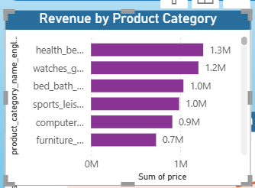
Explanation- Core Revenue Drivers: The horizontal leaderboard clearly identifies Health & Beauty (generating 1.3M), followed closely by Watches & Gifts (1.2M), and Bed, Bath & Table (1.0M) as the highest-grossing product segments for the storefront.
Strategic Growth Action: These three dominant categories represent the primary engines of cash inflow for the business.
Operational Value: Executive teams can use these insights to optimize supply chain inventory levels and focus marketing capital on these high-converting sectors to maximize future returns.

Task 2 - Delayed Orders Analysis: Determine the number of delayed orders in each category. An order is considered delayed if the actual delivery date is later than the estimated delivery date.
Visual-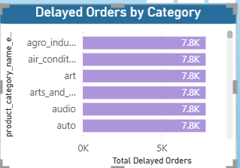

Explanation - Supply Chain Bottlenecks: The visualization maps out exactly where fulfillment processes are breaking down across product lines. Categories like Agro Industry and Commerce and Air Conditioning show elevated volumes of delayed deliveries, indicating backlogs.
Operational Action: Highlighting these specific operational gaps allows the logistics team to audit performance, identify high-risk suppliers, and adjust courier services.
Customer Protection: Addressing these localized delays directly reduces fulfillment times and boosts customer trust.

Task 3 -Monthly Fulfillment Trends Comparison: Perform a monthly comparison of delayed and on-time orders over the year to analyze operational consistency and seasonal capacity strains.
Visual-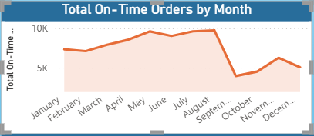

Explanation- Seasonal Capacity Strain: The chart isolates fulfillment consistency month-over-month. It highlights how promotional cycles and holiday shipping seasons impact transit workflows, showing where logistical strains cause spikes in delivery delays relative to total volume.
Predictive Scaling: Seeing exactly when processing timelines dip allows management to proactively scale warehouse labor and secure additional courier contracts ahead of known seasonal order surges.
Service Quality Control: Tracking this ratio dynamically ensures the store can maintain its core fulfillment promises to customers throughout the year.

Task 4- Payment Method Distribution Analysis: Investigate customer payment choices and distribution shares to analyze transaction habits and gateway reliance.
Visual- 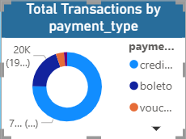

Explanation- Consumer Credit Reliance: The donut chart breakdown reveals that a vast majority of shoppers utilize credit cards and boleto (cash invoice payments) to finalize their store checkouts. Vouchers and debit cards make up a much smaller percentage of platform transaction volume.
Financial Optimization: Understanding this split allows the finance team to evaluate transaction fees from payment processors and negotiate lower operational processing rates on the most heavily used gateways.
Checkout Optimization: Confirming that credit cards and boleto dominate transaction options proves these methods must remain highly reliable to prevent payment friction and abandoned checkout carts.

Task 5- Product Rating Performance Analysis: Identify and evaluate customer review scores to isolate the highest-rated and lowest-rated product categories to track quality control.
Visual- 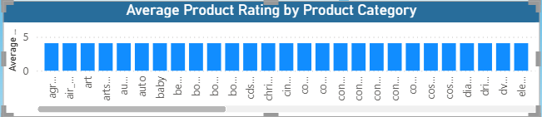

Explanation- Marketplace Quality Benchmarking: The visualization maps consumer sentiment averages directly to inventory category segments. It serves as an early-warning tracking mechanism for the store's operations.
Quality Assurance Audits: While top-scoring fields highlight highly successful products that protect brand reputation, categories trailing at lower satisfaction levels warn management of potential issues. These areas may need manufacturer quality audits, supplier evaluations, or more accurate website description details.
Customer Retention Strategy: Using continuous feedback loops helps the brand quickly discontinue defective batches and focus inventory capital on categories that drive repeat customer purchases.

Task 6- State-wise Sales Allocation Analysis: Analyze regional sales volume and performance geographically by customer state to map marketplace geographic density.

Visual- 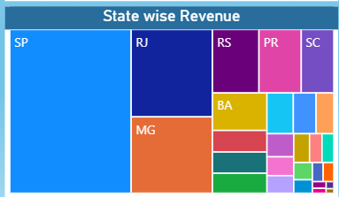

Explanation- Geographical Demand Concentrators: The treemap highlights high-density delivery hubs, showing that states like SP (São Paulo) and RJ (Rio de Janeiro) drive the vast majority of e-commerce revenue and order volumes.
Logistical Expansion Node Placement: Identifying these major hubs helps management place fulfillment centers closer to high-volume regions, reducing shipping distances, cutting delivery costs, and lowering transit times.
Targeted Regional Marketing: These insights help regional marketing teams focus advertising budgets and localization campaigns on high-conversion states, maximizing promotional return on investment (ROI).

Task 7- Seasonal Sales Trajectory (Quarterly Trends): Investigate and visualize any seasonal trends or quarterly patterns in sales data to track marketplace transactional flow over macro operational cycles.

Visual- 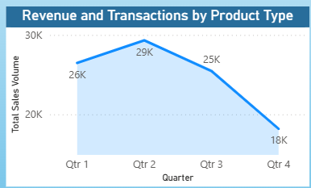

Explanation- Cyclical Purchasing Fluctuations: The line graph highlights distinct peaks and dips across seasonal quarters, clarifying that e-commerce traction is not entirely flat throughout the year. It exposes specific times when consumer shopping behaviors naturally spike.
Supply Chain and Capital Budgeting: Recognizing these cyclical macro shifts allows the executive team to manage manufacturing streams, build up warehouse stock before historical peak quarters, and adjust cash flows during slower quarters.
Promotional Campaign Scheduling: These data trends help marketing teams schedule major store discount periods and ad spend to align with organic shopping surges, maximizing gross sales numbers.

Task 8- Executive Revenue Analysis Overview: Determine total revenue generated by the storefront and establish high-level benchmarks to track business health and gross economic performance.

Visual- 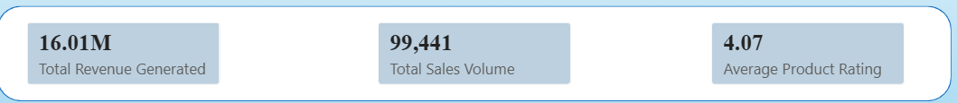

Explanation- Aggregate Financial Benchmark: The KPI block establishes a grand aggregate total of 16.01 Million in revenue generated across the active history of the dataset. This stands as the absolute foundation metric for company growth calculations.
Executive Decision Gate: This high-level number acts as the main gauge for financial health, giving stakeholders and leadership teams a clear metric to evaluate long-term profitability and plan future corporate scaling strategies.
Data-Driven Valuation Models: Consolidating this gross performance indicator right at the top of the canvas gives a reliable tool to track company milestones and justify strategic expansion projects to investors.

